EMOTIONS PACKAGE

1. Open Sims 4 Studios

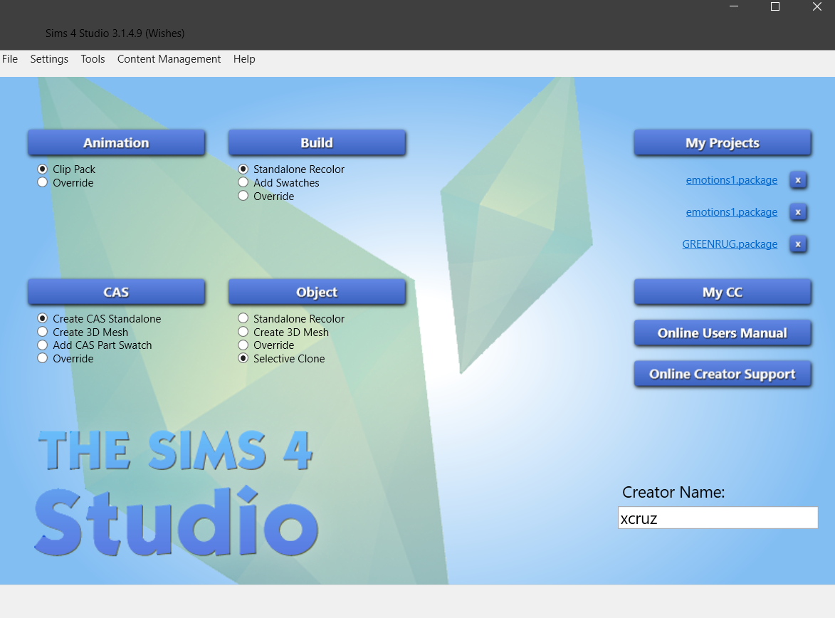

1. Select – „Selective Clone“ and „Object“-Button

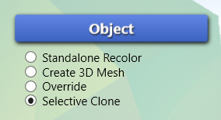

1. Select any object and click on “Next”

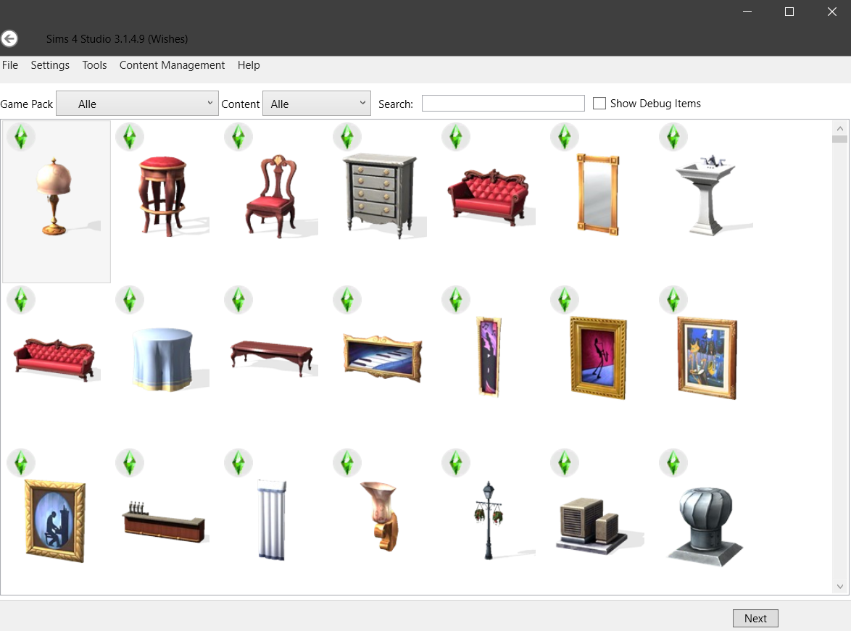

1. Save your package in your Sims Mod folder to use it afterwards – if not drag and drop it in your mod folder
2. Make sure you checked these boxes:

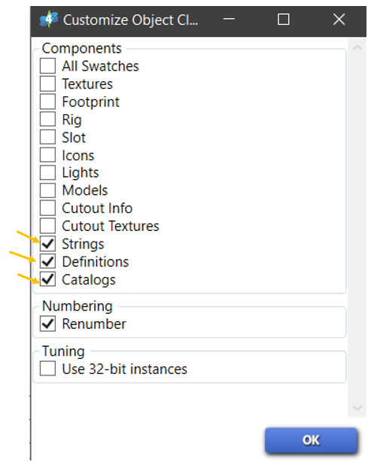

1. Select „Tools“ in the upper left side

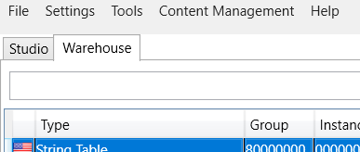

1. Select “Extract Tuning…” to select Buff (Emotion) to inject

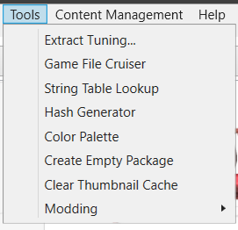

1. Search bar pops up – search for wanted buff
   1. Keep in mind that is has to be in this format buff/xxx..

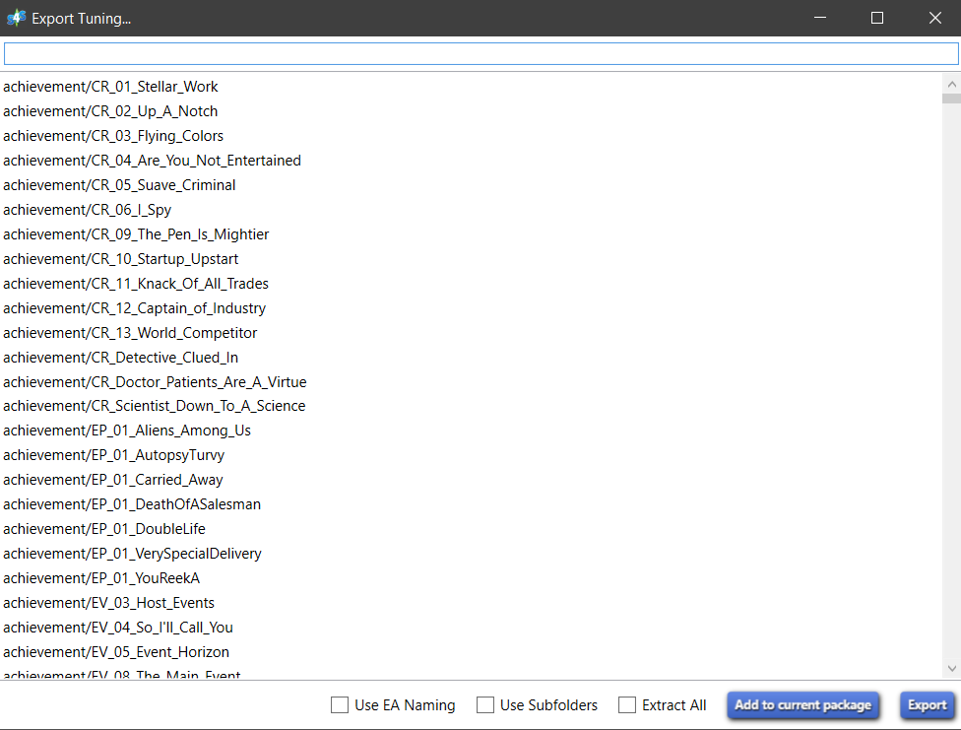

* 1. Example: happy

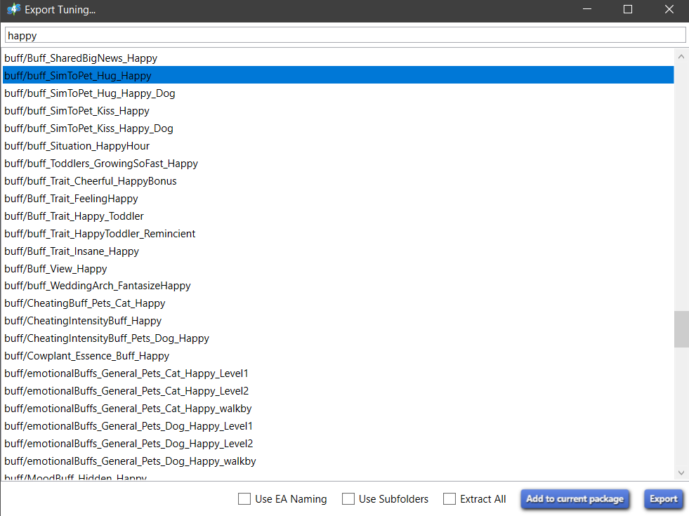

1. If Buff is found 🡪 Click “Add to current package”



1. Depending in which language you play The Sims 4 – select string table according to language
2. You can now add strings (texts) which are shown if emotion is injected – click “Elemente bearbeiten” to add

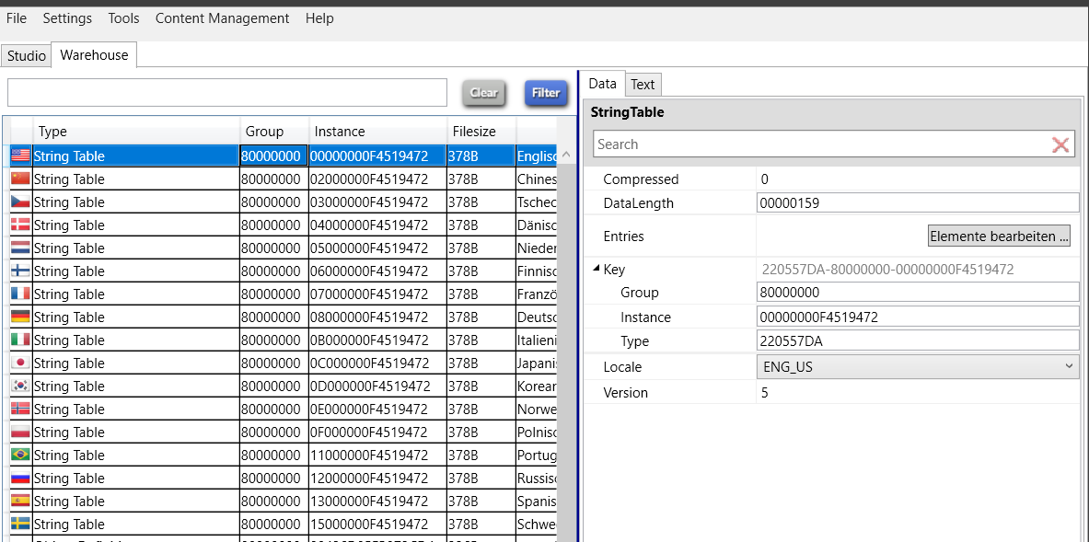

1. Click “Add” to add a new string – the “Key” is a hexadecimal and ID for this string, while the “Value” is the actual string to show
   1. If you need a hexadecimal number go back and select “Tools” again – click “Hash Generator” to generate number to use
   2. You can choose whether to use a simple decimal number for the ID or let the generator generate a hash made out of the text – in this case you can get the generated hash (mostly used “FNV32”)
   3. Using this hash for “Key” you’re ready to add this to as your key and add a string – don’t forget to save afterwards
   4. Add as many as you want/need!

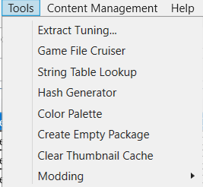

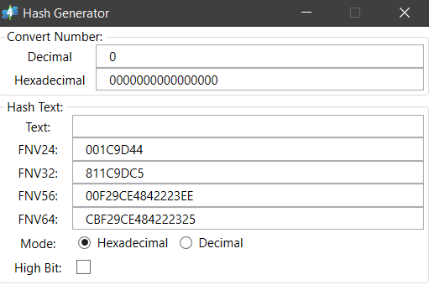

* 1. Example:

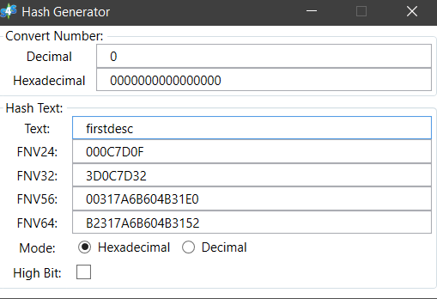

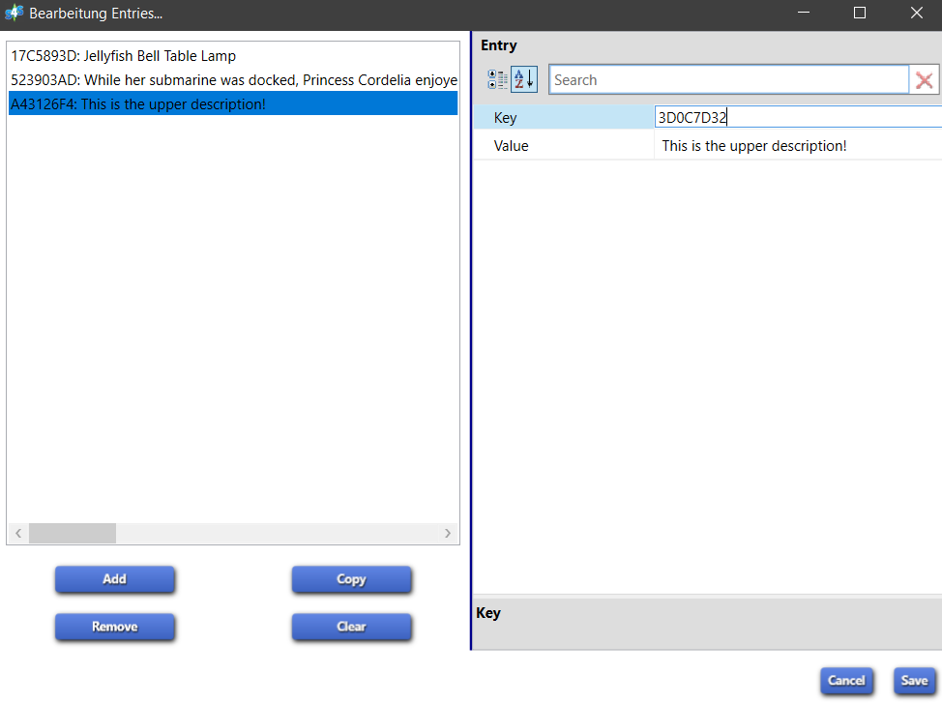

1. Select Buff Tuning of your added Buff to see the XML

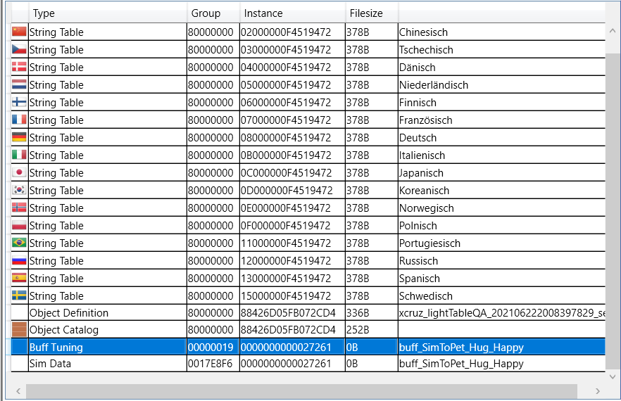

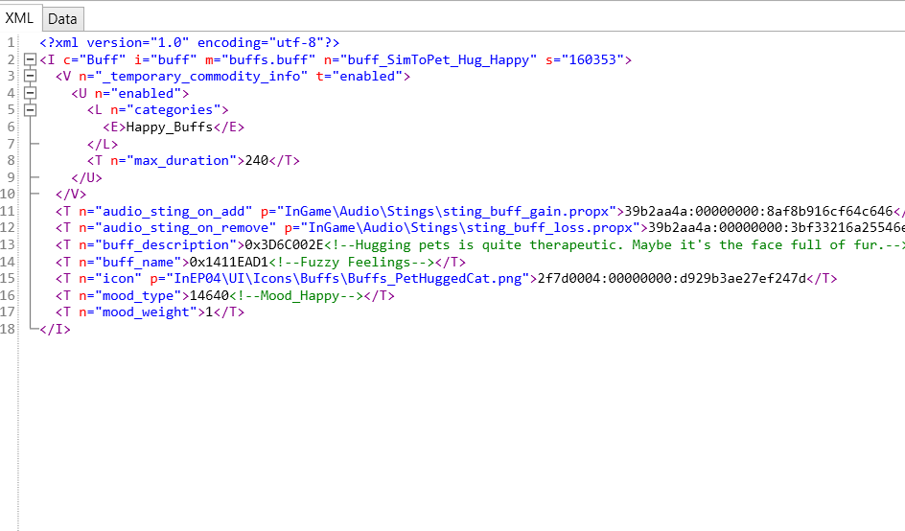

1. To add first description change current hexadecimal number with generated hash – make sure to select correct string ID for this one!

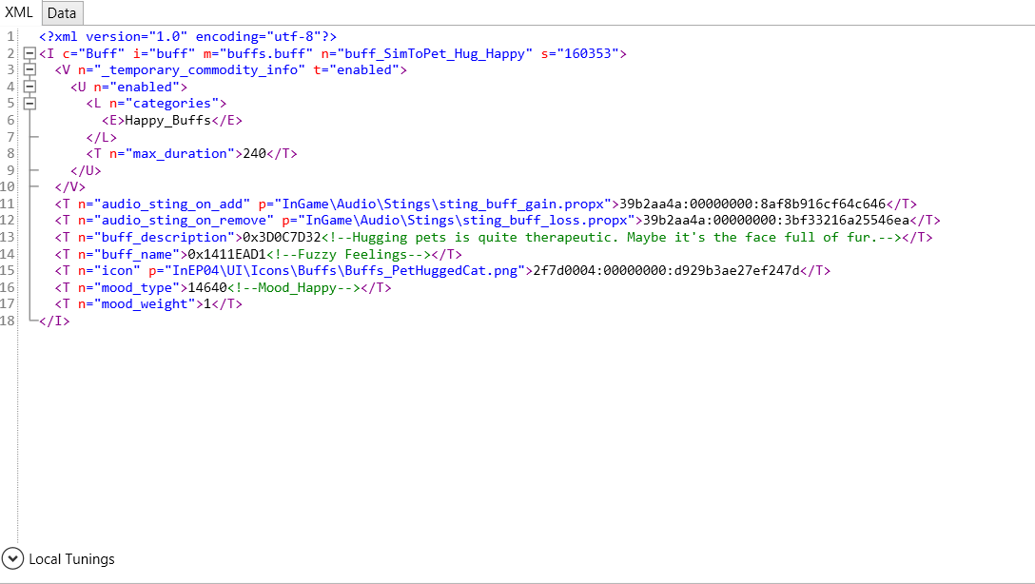

1. Now select Sim Data to change/delete title (or name) and lower description
   1. Change Title 🡪 change hexadecimal with generated hash – make sure it’s the correct ID
   2. Change lower description 🡪 change hexadecimal with generated hash – again make sure it’s the right ID
   3. Delete Title/lower description 🡪 change hexadecimal to 0x00000000

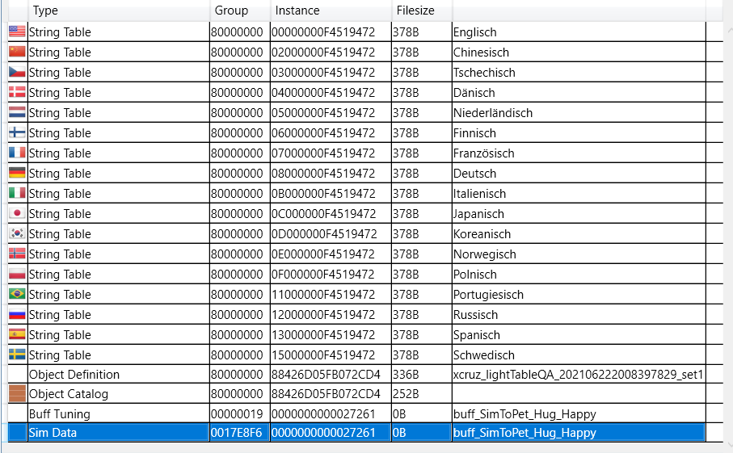

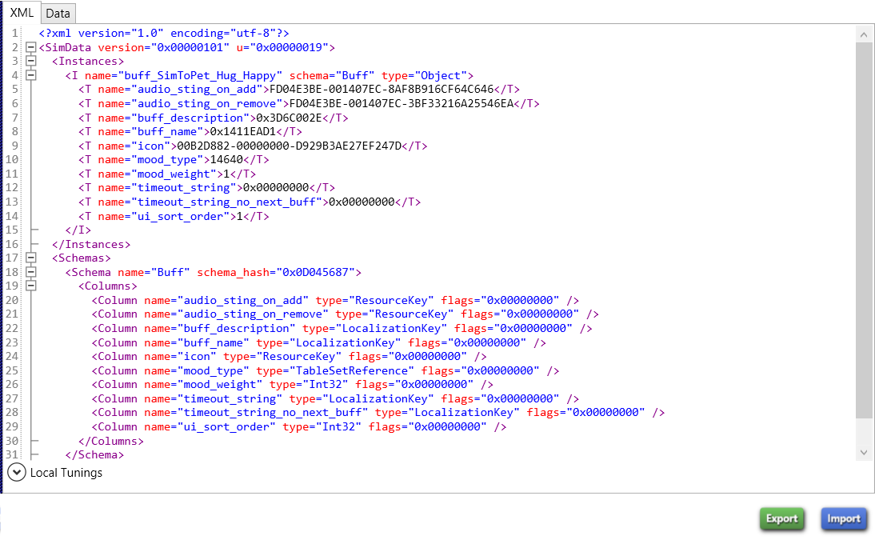

* Change Title and lower description

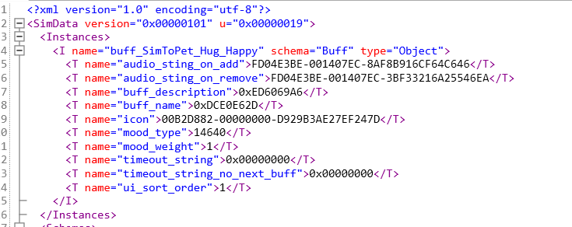

* “Delete” title and/or description

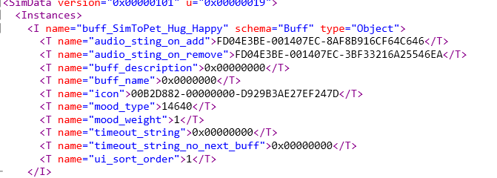

1. Save your package with Ctrl+S
2. To add to your Mod – add following line to your code, where you want it to inject it
   1. First decimal number is the Instance ID of added buff – to find it select Buff Tuning again, but this time go to Data
   2. Instance is a hexadecimal number – “hash generator” let’s you convert this!
   3. Copy paste result and insert as first number
   4. The second number – buff reason is the string you want to insert!
   5. Convert the hexadecimal ID from your string and insert it there

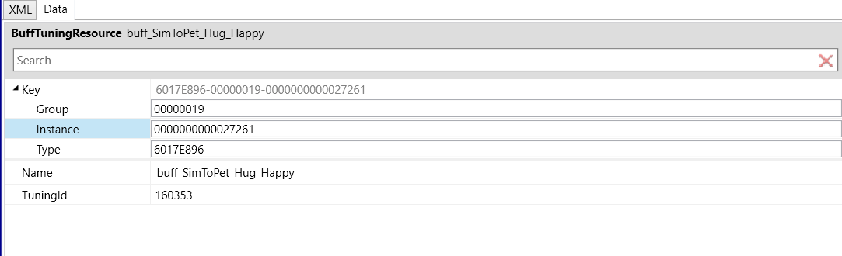

* Result

CommonBuffUtils.add_buff(CommonSimUtils.get_active_sim_info(), 31038,  
 buff_reason=CommonLocalizationUtils.create_localized_string(1024228658))

1. Don’t forget to compile your script.py!
2. You can now start sims and enjoy your buff!

